- Place Both programs in desired folders
- Edit the following code line
In the program named GLA_Fitting_GUI_v1p7, change the directory heading to point where the program named Function_Library_RH_v1p11 is located
- Run GLA_Fitting_GUI_v1p7
- In the left window all of the fitting parameters and functions are located, plots will appear to the right after fitting.
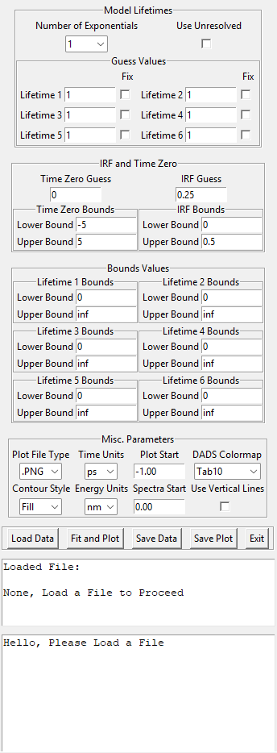
- Number of lifetimes and whether to use an infinite component are at the top
- Guess values are entered for each lifetime in the guess value box (defaults to 1) checking the box will fix the lifetime at the guess value
- Guess values for time zero and IRF are in the next box, as well as bounds for those guesses
- Bounds for the guesses for each lifetime are entered in the bounds box, use inf to indicate infinity or unbounded
- Misc parameters allows changing how the plot is saved when the save plot button is used, changing of the time delay the contour plots start at, what time unit the representative spectra plot will start at, coloring for the DADS, contour plot style (filled or outline), energy units (nm or eV), time delay for the first representative spectra (approximate value), and whether to overlay vertical lines in the data where the kinetic traces are taken from.
- The button lets data be loaded with the load data button, can access CSV or UFS file extensions, Fit and Plot will fit and then plot the fitting results in screen, save data will save CSV files of the DADS, and Fit surface, Save plot will save a copy of the right plot in the selected file format from the misc settings, and Exit will close the program
- Window below buttons indicates what file is loaded
- Bottom most window tracks progress of fitting and reports errors

